INTERNATIONAL CONFERENCE ON LAKE CHAD

CONCEPT NOTE

Theme :
Saving the Lake Chad to revitalize the Basin’s ecosystem for sustainable livelihood, security and development

TABLE OF CONTENTS
1.0 BACKGROUND 3
2.0 RESPONSE TO THE ENVIRONMENTAL DISASTER 4
3.0 THEME OF THE CONFERENCE 6
a. SUB-THEMES OF THE CONFERENCE 6
b. OBJECTIVES 6
4.0 METHODOLOGY 7
4.1. CONTENT OF PAPERS: 8
4.2. KEY NOTE ADDRESSES 8
4.3. TECHNICAL PAPERS 10
4.4 ROUND TABLE………………………………………….…………………………..10
5.0 ROLES OF KEY PARTNERS 10
5.1. FEDERAL GOVERNMENT OF NIGERIA 10
5.2. UNESCO: 10
5.3. LAKE CHAD BASIN COMMISSION: 10
5.4. OTHER PARTNERS AND TENTATIVE DONORS: 10
6.0 PERIOD-DURATION 11
7.0 BUDGET 11
8.0 FUNDING (Including in-kind) 11
9.0 EXPECTED OUTCOMES OF THE INTERNATIONAL
CONFERENCE 12
ANNEX 1:MAP OF THE LAKE CHAD CATCHMENT AREA 13
ANNEX 2:LAKE CHAD SURFACE AREA VARIATION 14
ANNEX 3:MILESTONES AND TIME LINES 15

BACKGROUND

The Lake Chad Basin which is shared by Algeria, Cameroon, the Central African Republic, Chad, Libya, Niger, Nigeria, and Sudan (see map attached as annex 1) is a large entity representing about 8% of the total size of the African continent, with a population estimated at 40 million inhabitants according to statistics of 2010. It is an essential water resource for fishermen, livestock farmers and farmers of the riparian countries most of them among the poorest in the world.
Despite poverty and the security challenge in the Lake Chad basin area, this fresh water body is a source of water supply for drinking and a sound environment conducive to socio-economic development. It also offers a unique social and cultural environment contributing to the rich diversity of the region. Lake Chad riparian populations have their cultural values, beliefs and traditional practices shaped by their relationship with the natural environment and therefore influencing environmental sustainability.
However, Lake Chad is facing a myriad of onerous challenges. In the sixties, its surface area was 25,000 km² with about 135 species of fish and an annual production estimated at 200,000 tonnes. It was the epitome of productivity, food security and wealth to the people residing in the basin and beyond. In Chad alone, it was estimated that there were about 20,000 commercial fish sellers at the period. As of today, the lake is a source of insecurity, instability, and loss of livelihoods.
Prior to the drought, in the 1960s, the best grazing land was in the Sahel zone of the Lake Chad Basin. The Sahel was good for extensive herding as there was rarely conflict with crop farming and it was estimated that seven (7 ha) hectares of land could feed one Tropical Livestock Unit for six (6) months of the year. The drought led to the loss of pasture and the initiation of the transhumance migration towards the guinea savanna in the south of the basin.
Unfortunately, Lake Chad is experiencing variability in size due to both human pressure and adverse effects of climate change. Its size has reduced from 25,000km² in the 60s to 2,500 km² in 1985 due to the combined effects of climate change and the unsustainable water and natural resource management. However, in 2013, the surface area of Lake Chad has increased to 5,000 km² following an exceptional improvement of the rainfall pattern.

A review of the hydrology of the Lake Chad Basin shows that the wet years (before 1973) inflow averaged between 30 – 40 Km³ per annum, while the dry years (after 1974) inflow averaged 20 - 21 Km³ per annum while the lowest was 16 Km³ recorded in 1984. The current Basin Water use as at 2011 is estimated at 2 Km³ per annum.

RESPONSE TO THE ENVIRONMENTAL DISASTER

Facing the increasing degradation of Lake Chad ecosystem, the respective Governments of LCBC’s member countries took the following major measures:
- The African Ministers’ Conference on the Environment (AMCEN) in 1985 agreed to support the Lake Chad Basin Commission for an integrated development of the basin with the aim of halting the shrinking of the Lake and effective use of its natural resources.
The Heads of State and Government of the Lake Chad Basin at the 10th Summit held in N’djamena, Chad on 28 July 2000 agreed to mobilize six million ($6m) US dollars for the feasibility study of Inter Basin Water transfer from Ubangi River in Central African Republic to the Lake Chad. To this effect, Nigeria supported the study with a grant of $5m. The study has proven that the Inter Basin Water transfer is feasible, but it is capital intensive and a long term project. The study indicated that the lake inflow could be augmented by an additional 3.5 Km³ which could raise the annual inflow between 23.5 to 24.5 Km³.
- The LCBC Strategic Action Programme (SAP) was approved in 2008 and its implementation began with funding from AfDB and LCBC member States in the PRODEBALT Project;
- A Five-year Investment Plan (FYIP 2013-2017) aimed at safe guarding the ecosystem of the basin was adopted at the 14th
Summit of LCBC Heads of State and Government held in N’Djamena, Chad on 30th April 2012. The plan had the following components:
- inter-alia, water transfer project from Ubangi River to Lake Chad;
- sensitization on the sustainable use of the natural resources and the preservation of the ecosystem of the Lake Chad Basin;
- strengthening stakeholders participation and implementation of the Lake Chad Basin Water Charter; and
- Implementation of the National Action Plan (NAP) for the Integrated Water Resources Management (IWRM) of the Lake Chad Basin member countries.
- A donor conference with the aim of raising funds for the implementation of the Five-Year Investment Plan and the National Action Plan (NAP) was held in April 2014 in Bologna, Italy. The African Development Bank (AfDB) supported the initiative by providing the amount of 53. 82 UA (Unit of Account)The other partners contribute the sum of 17.41 Million UA, or a total of 71.23 Million UA (USD 110.4 million).
The implementation of the NAP has commenced in Nigeria where the riparian States of the Basin have taken up the challenge to address the current issues by setting up a Trust Fund to implement activities contained in the Catchment Management Plan of the Komadugu-Yobe Basin (KYB).
- The Lake Chad Basin Water Charter was approved in 2012 by the LCBC Summit of the Head of State and Government as legal instrument for water management of the Lake. All LCBC’s member countries have ratified the charter except Libya and CAR that are in the process of doing so.

- Recently, LCBC and its six-member countries: Cameroon, Central African Republic, Chad, Libya, Niger, and Nigeria with support from the World Bank Group and in coordination with the French Development Agency/Agence Française de Development (AFD), have prepared the Lake Chad Development and Climate Resilience Action Plan (LCDAP) for the period of 2016- 2025. The core idea of the Plan is that, in parallel to the restoration of peace and security, there is a need to turn Lake Chad into a pole of regional rural development.
The Lake Chad basin has a huge and untapped socio-economic potential. These resources include the following:
  - Agricultural lands;
  - Fishery and pastoral potential;
  - Groundwater;
  - Mining resources;
  - Hydrocarbons
  - Tourism
Despite all these measures, the major challenges facing the Lake Chad region remain. Hence, the need to organize an international conference with a view to reversing the trend.

3.0 THEME OF THE CONFERENCE
“Saving the Lake Chad to revitalize the Basin’s ecosystem for sustainable livelihood, security and development.”

Sub-Themes of the Conference
- Restoration of Lake Chad: Scientific and Technical innovations;
- Lake Chad Water Transfer: prospects, challenges, and solutions;
- Social, environmental, cultural, and educational aspects in the current context;
- Security and regional cooperation aspects with a view to restoring peace in the Lake Chad basin;
- Funding of approved options.

b. Objectives
The main objective of the International Conference is to create global awareness on the socio-economic and environmental challenges arising from the shrinkage of the Lake Chad, threat to livelihoods inducing insecurity with a view to developing a comprehensive programme for action to save the Lake from extinction.
The specific objectives of the conference are as follows:
- To inform stakeholders, discuss and develop consensus on the different solutions to restore Lake Chad, including the Inter Basin Water Transfer (IBWT) Project from the Ubangi River to the Lake Chad;
- To bring together experts, political decision makers, donors, UN Specialized Agencies, scientific and technical experts, Civil Society, NGOs and researchers to exchange knowledge and share information on water resources development and management in a crisis environment for sustainable development in the Lake Chad Basin;
- To garner political and financial support, for the restoration option identified for of the Lake Chad.

4.0 METHODOLOGY
The conference shall consist of plenary sessions, technical sessions, and a high-level round table.
The sequential structuring of the conference is as follows:
- Opening plenary session: This session focuses on key note addresses on general and/or strategic orientations, concept clarifications and possible paradigms proposed likely to guide new intervention approaches to achieve more significant results;
- Thematic sessions: These sessions will focus on all issues and technical solutions towards safeguarding and restoring Lake Chad to enable it to play its role fully consisting of both regulating the environment (ecosystems) and sustainably improving the living conditions of the populations of the basin;
- Round Table: This high-level round table will focus on the presentation of the conclusions of technical sessions which should pave the way for pragmatic and landmark recommendations.

4.1 Contents of papers:
  - Opening plenary session: This session will focus on two (2) significant papers. The first paper, by LCBC, will deal with challenges, prospects, and opportunities as part of safeguarding the Lake Chad. The second paper, by UNESCO is dealing with strategic orientations and relevant approach to engage a new dynamic of solutions to be proposed towards saving Lake Chad. These introductory notes will enable participants to better understand the expected results of the conference;
  - Technical or thematic sessions: These sessions will deal with papers on various topics relating to the issue of safeguarding of the lake and the role of sustainable development assigned to Lake Chad. Topics related to Lake Chad replenishment to be integrated in a coherent framework with the different possibilities to be explored (including Inter-Basin Water Transfer Proposal). Topics relating to water infrastructures to be preceded by a paper on the exhaustive inventory of existing infrastructures in the Lake Chad basin with a prospect on the possible impact of the restoration of the lake.

4.2. Key Note Addresses:
- Overview: Saving the Lake Chad, Prospects, challenges, and opportunities - LCBC.
- Saving the Lake Chad to revitalize the basin ecosystem, for sustainable livelihoods, security and development. UNESCO;

4.3. Technical Papers
i. Integrated Water Resources Management (IWRM, UNESCO): Case study of the Lake Chad Basin;
ii. IBWT prospects and opportunities:

  - Chinese case study (Power China);
  - Aral Sea case study;
  - Bonifica Transaqua concept;
  - LCBC/CIMA International -Feasibility Study of Ubangi Water Transfer.
  - Ubangi – Lake Chad Water Transfer Using Solar Option by Engineer Guy Immega
  - The Trans Africa Pipeline (TAP) and Recharging the Lake Chad by Trans Africa Pipeline Inc, Canada.

iii. Ubangi to Lake Chad Inter-Basin Water Transfer and International Diplomacy –by Francois KALWELE, ARD/ClREP - Ministry of the Environment of Democratic Republic of Congo.
iv. Environmental, social, and cultural framework for the implementation of Large Water Infrastructure. Presentation by UNEP;
v. Funding options for the restoration of Lake Chad.

- An overview of financing Water Infrastructure in Africa by AfDB;

- Great man-made River Project - Libya Case Study

- Great Renaissance Dam – Ethiopia Case Study

- SUEZ Canal – Egypt Case Study

- Other options: Case study of DRC with Climate Funds (REDD+, Green Funds etc) by ARD / ClREP - Ministry of the Environment of Democratic Republic of Congo.
vi. Capacity building for sustainable Water Management. Presentation by Category II-Regional Centre on Integrated River Basin Management.
vii. The link between environment degradation, loss of economic opportunities and livelihoods and security issues by LCBC;
- Dynamic of the water resources within the Lake Chad Basin.
Presentation by speakers from member state institutions (Chad, Niger, Nigeria, and Cameroon) – Presenter to be determined;

- Transboundary water diplomacy, culture of peace and Lake Chad with international site status as Biosphere Reserve and/or World Heritage site. Presentation by UNESCO;
- Sustainable water uses for food security in the Lake Chad Basin. Presentation by Food & Agriculture Organisation (FAO);

4.3. Round Table
The high-level round table will focus on the following:
- Presentation of the report of the Technical Session and;
- Recommendations

5.0 ROLES OF KEY PARTNERS
Federal Government of Nigeria, UNESCO, LCBC and relevant donors

5.1. Federal Government of Nigeria
- Funding;
- Lead, coordinate and facilitate the conference.

5.2. UNESCO:
- Collaborate with Federal Government of Nigeria and LCBC to identify key speakers and provide technical support;
- Involve relevant UN Agencies in the conference organization.
- Ensure adequate dissemination of the conference through UNESCO appropriate channels;

5.3. Lake Chad Basin Commission:
- Provide financial and logistic support for the conference;
- Facilitate the participation of the LCBC member States and other Stakeholders in the conference;
- Advocacy;
- LCBC’s Champions:
i. Major General Olusegun Obasanjo (Rtd), Former Nigerian President;
ii. Mr.Boukary Adji – Former Prime Minister, Niger Republic.

5.4. Other Partners and Tentative Donors:
- AfDB;
- World Bank;
- ECCAS;
- ECOWAS;
- AMCOW;
- AMCEN
- German Government & Cooperation Agency (GIZ);
- Government of Democratic Republic of Congo;
- Government of the Republic of Congo;
- Government of Algeria;
- Government of Egypt;
- Government of Canada;
- Government of China;
- Japanese International Cooperation Agency (JICA);
- Korean International Cooperation Agency (KOICA);
- Government of Norway;
- African Union;
- European Union;
- Congo Basin Commission (CICOS)
- Multinational Joint Task Force (MNJTF)
- UNDP, UNEP, UNICEF, FAO (fishing, forestry), ILO and;
- Private Sector

6.0 PERIOD-DURATION
Three (3) days meeting consisting of two (2) days Technical Sessions and one (1) day High Level Summit subject to approval by the Heads of State and Government of LCBC. The conference shall hold from 26th – 28th February 2018.

7.0 BUDGET
To be worked out by different sub-committees and be consolidated into a central budget.

8.0 FUNDING (Including in-kind)
- Federal Government of Nigeria;
- UNESCO;
- LCBC’s Executive Secretariat;
- AfDB;
- FAO;
- UNEP;
- World Bank;
- AU,
- ECOWAS;
- The private sector and; •Other relevant donors.

9.0 EXPECTED OUTCOMES OF THE INTERNATIONAL CONFERENCE
- At the end of the international conference all relevant stakeholders scientists, experts, bilateral & multilateral donors and UN specialized agencies are expected to work in harmony with CBOs, NGOs and other concerned donor and partners who would build on previous conferences and studies towards quick realization of the following:
  - Restoration of the shrinking lake to an environmentally sustainable level as a way to save it;

  - Restore fishing and irrigated farming/agriculture along the Lake and along the River Chari with a goal of alleviating poverty;

  - Strengthening climate resilience in the basin through adaptation and mitigation programmes;

  - Foster transboundary cooperation among member countries for sustainable management of Lake Chad;

  - Create employment, leading to reduction of terrorist activities;
  - Increase revenue of the populations living in the Basin;

  - Increase GDP of the countries of the Basin.

  - Implement programmes for the efficient use of water;

- Develop a road map for the implementation of the recommendations of the conference.

ANNEX 1: MAP OF THE LAKE CHAD CATCHMENT AREA
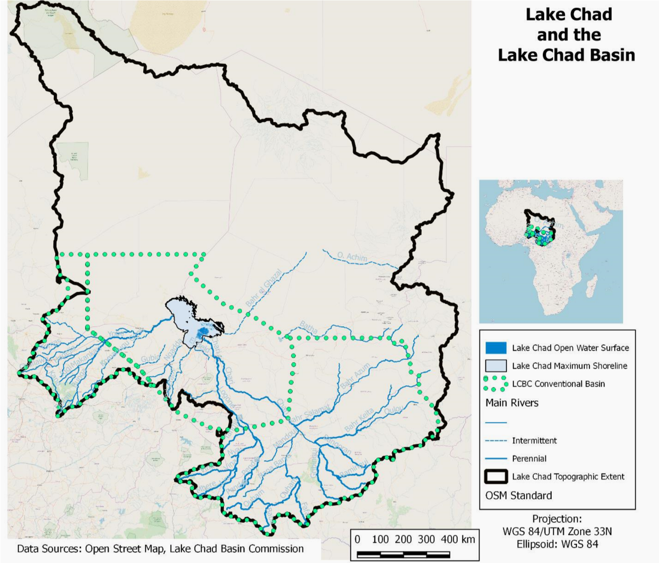

ANNEX 2: LAKE CHAD SURFACE AREA VARIATION
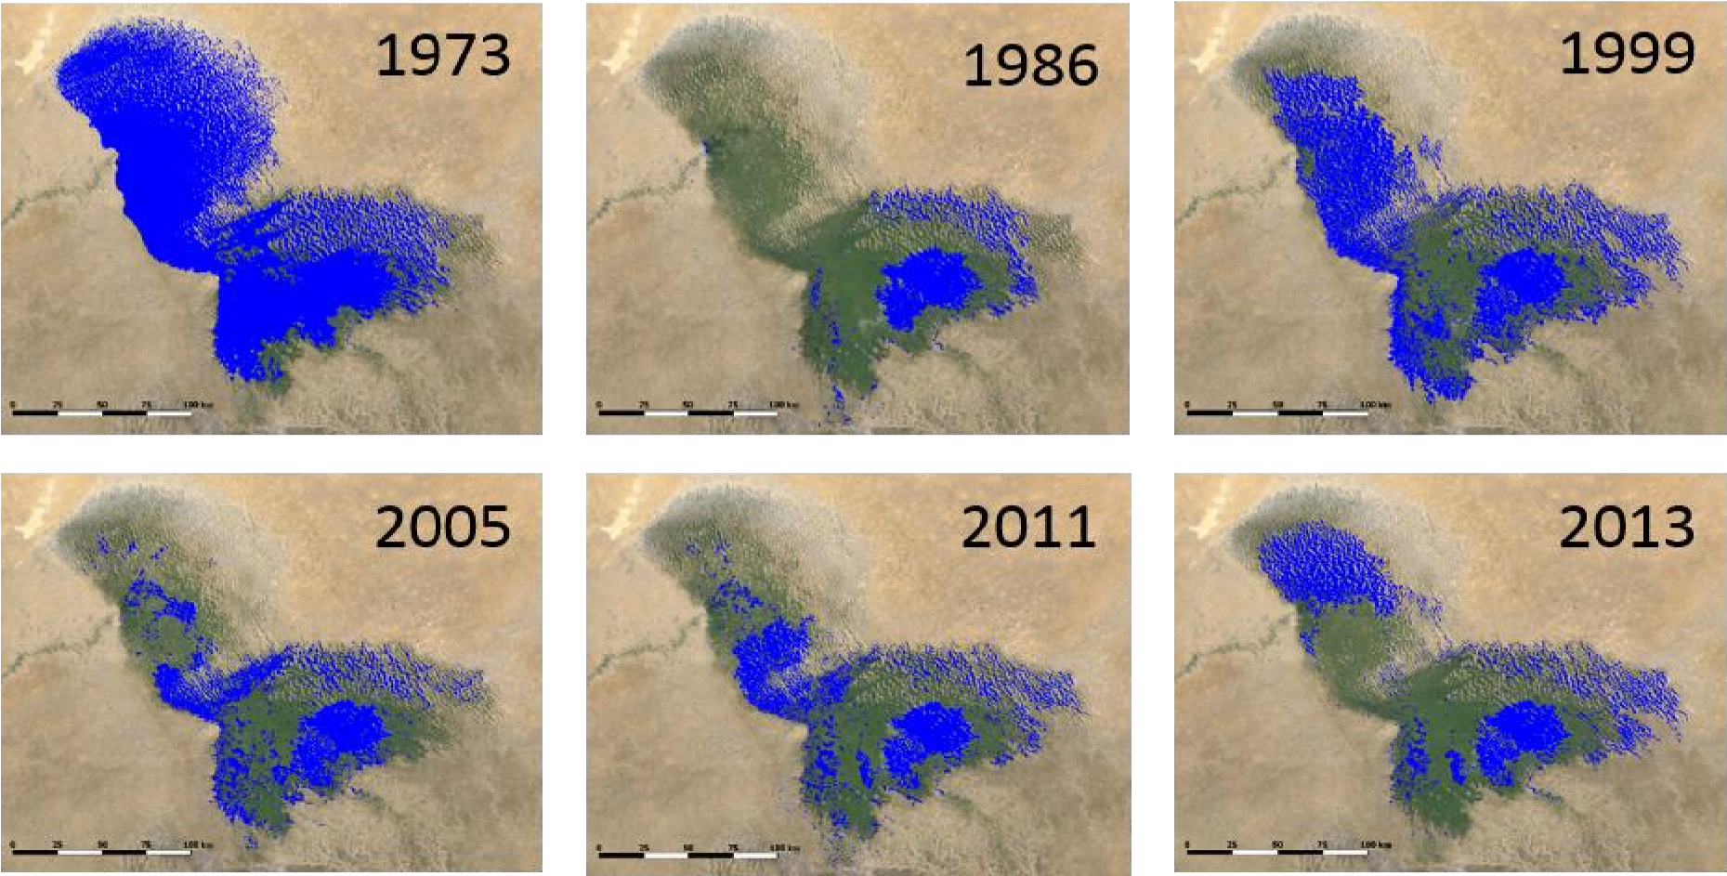

ANNEX 3: MILESTONES AND TIME LINES
 | MILESTONES AND TIME LINES
 | SCHEDULE | DESCRIPTION | ACTION REQUIRED | RESPONSIBILITY | OUTCOME | TIME LINES | STATUS | REMARKS
1 | DATE OF  CONFERENCE | DATE FOR THE CONFERENCE | Determine date for Conference after  due consultation  with all stakeholders | LOC | 26th – 28th February,  2018 |  | To be confirmed by LCBC Heads of State and Government
2 | Produce budget for the  Conference | Every  Subcommittee should meet and  draft line items  (based on phases) and budget for  recommended  activities and submit to the Local  Organizing  Committee | Approvals of the budget to be facilitated by the Chairman, after collation by the LOC:  1. Submission of budget by each  subcommittee  2. Subcommittees should work with the Facilitator to get vendors to execute line items | LOC Chairman,  Chairmen of Subcommittees, and Facilitator | Adhere strictly to the budget. Further negotiations at the point of sale to get quality service and cost-effective prices on services to be rendered. | 15thSeptember- 31st November ,  2017 | Ongoing
3 | Open Conference Account and Determine Financial Management Process | Open Conference Account and Determine Financial Management Process | 1. Select Bank(s) to be used  2. Designated signatories to the account(s)  3. Design a financial management 4process  4. Open Conference Account(s)  5. Determine funds disbursement process  6. Communicate process to Sub-committees  7. Agree on milestones and phases for disbursement of funds | Finance Sub-Committee | Account(s) Management | 20th November – December 31st , 2017 | Ongoing
4 | Validation Workshop | A Workshop to Validate Conference Concept Note to hold in N’djamena, Republic of Chad, with Participants from seven Lake Chad Basin Countries | 1. The LOC and Sub-Committees to work with LCBC to plan and execute the workshop  2. Identify Participants from Nigeria and Communicate to LCBC. | LOC | Approve Final Concept Note | 9th – 13th October, 2017 | Concluded
5 | Selection of Topics, Speakers, Facilitators, Discussants and Rapporteurs | Formulation of Relevant Topics and Identification of Qualified Speakers, Facilitators, Discussants, Session Chairpersons and Rapporteurs | Vetting and Approval by the LOC | LOC Technical Subcommittee, member countries and Facilitator | List of Topics, Speakers, Facilitators, Discussants and Rapporteurs | November – December, 2017 | On-going
6 | Call for Papers | Announcement for Specialists, Experts and Reviewers to Indicate Interest in Selected Conference Topics | 1. Posting the Call for Papers on the Conference Website, Local and International Print Media, Professional Journals, etc  2. Approve Rates of Honouraria for Specialist, Experts and Reviewers. 3, Contact Identified and Interested Specialists, Experts and Reviewers. 4. Convey Approval of Topics 5. Establish Deadlines for Submission and Review of Papers | Technical, Finance and Media & Publicity Subcommittees, LOC and Facilitator | 1. Papers, Presenters and Reviewers Confirmed 2. Honoraria Rates Confirmed | September 27th – December, 2017 | on-going
7 | Conference Kit | Programme of Events, Papers, Instruction Materials, Information Materials, Stationery, Name Tag, etc for Participants | 1. Reproduce Conference Papers and other Materials ahead of Arrival of Participants. 2. Obtain Relevant Materials from Ministry of Information, UNESCO and LCBC  3. Prepare and Make Available Conference Kits to Participants Upon Arrival. | Technical and M&P Subcommittees, LOCand Facilitator | Required Number of Kits Ready Ahead of Conference | 1st Week of February, 2018 | Pending
8 | Invitations | Drafting and Approval of Invitation Letters and Cards. | 1. Drafting and Approval of Invitation Letters and Cards.  2. Design and Embed Tracker on Conference Website  3. Dispatch Invitation Letters and Cards to Participants, Dignitaries and other Invitees.  4. Track Committed Participants, Dignitaries and Invitees | LCBC | List of All Participants, Dignitaries and other Invitees Ready | November 2017 – January 2018 | Ongoing
9 | Registration | Participants to Register Online | 1. Agree on the format of Online Registration 2. Embed the format on the Conference Website 3. Advertise Registration in the Mass Media | LOC, Technical and Media & Publicity Subcommittees and Facilitator | Commencement of Registration | November 26 – February, 2018 | Ongoing
10 | Visa and Immigration | Send Letters to The Nigeria Immigration Service and Nigeria High Commissions and Embassies informing them about the Conference for Visa Facilitation and Border Clearance. | 1. Draft and Approve Visa Introduction Letters  2. Dispatch Letters to The Nigeria Immigration Service (NIS), Nigeria High Commissions (NHCs) and Embassies. 3. LOC to indicate on Letters of Invitation the Process of Applying for Visa on NIS Website. | LOC Secretariat | Liaise with NIS and NHC for Visa Facilitation and Border Clearance. | January 3 – Feberuary 26, 2018 | Ongoing
11 | Media and Publicity | Creation of Media Plan and Partnership with Traditional and Online Media | 1. Develop a Media Plan. 2. Enlist Media Partners. 3. Negotiate Rates. 4. Organise Press Conferences and Regular Updates 5. Publish Daily Conference Bulletins  6. Engage Media Houses and Social Media Influencers 7.Media Buying and Monitoring.  8. Open Social Media Accounts (Facebook, Twitter, Instagram and Bulk SMS for Participants).  9. Design Banners and Backdrops. | Media & Publicity Subcommittee, LOC and Facilitator | Robust Conference Media Presence and Awareness. | November 2017 – February 2018 | Ongoing
12 | Press Kit | Information Package on the Conference, Sponsors, Principal Participants and Programme of Events | 1. Assemble Information on Lake Chad and its Challenges, Preparations for the Conference, Background Information about Sponsors, Principal Participants and Earlier Conferences  2. Ensure Kit is Ready and Distributed to all Media Outlets ahead of the Conference | Technical, Media & Publicity Subcommittees, LOC and Facilitator | Informed and Positive Media Coverage Before, During and After the Conference | November 2017 – 2nd Week of February, 2018 | Ongoing
13 | Establish Conference Website - Design and Management of Website | Design, Establish and Manage Conference Website | 1. Vendor to Deliver Website 2. Selection of Website Administrator. 3. Regular Uploading and Update of Content | Technical, Media & Publicity Subcommittees, LOC and Facilitator | Robust Online Presence and Up-to-date News and Information on the Conference | September 27 2017 – 26th February, 2018 | Ongoing
14 | Air Transportation | 1. Securing Partner Status with some Airlines and Travel Agencies. 2. Obtaining Flight Schedules into Lagos and Abuja. 3. Upload the Information on the Website | 1. Securing Partner Status with some Airlines and Travel Agencies. 2. Obtaining Flight Schedules into and out of Lagos and Abuja. 3. Upload the Information on the Website | Logistics & Transportation, Protocol & Security Subcommittees and Facilitator | Efficient and Convenient Air Transportation Arrangement . | January 4 – February, 2018 | Ongoing
15 | City Transportation | Vehicular Movement of Dignitaries, Speakers, Facilitators, Discussants, Rapporteurs, Other Participants and LOC Members | 1. Establish the Itenarary of Invited Participants. 2. Identify Requirements for Local Transportation.  3. Identify and Engage Local Transport Companies 4. Plan and Assign Vehicles taking into Account Order of Protocol, Need, and Convenience 5. Establish Vehicle Requirements of LOC Members  6. Arrange Airport Pickups and Drop offs 7. Arrange Hotel Shuttle. 8. Arrange Movement of Other VIPs. | Logistics & Tansportation, Protocol & Security Subcommittees and Facilitator | Final Schedule of Local Transportation | 24th January to 28th February, 2018 | Pending
16 | Reservation of Conference Venue and Accommodation | 1. Conference Venue -Transcorp Hilton  2. Accommodation - Transcorp Hilton, Summerset, Rockview, Chelsea, Barcelona, Ajuji, etc | 1. Determine number of rooms for Accommodation and Syndicate Sessions 2. Ensure Bookings and Reservations at The Hilton and other Hotels  3. Pay Deposits for Booked Rooms and Venues 4. Make Final Payments According to Agreed Schedules. | Venue, Entertainment & Accomodation, Protocol & Security Subcommittees, LOC and Facilitator | Deposit to be paid to secure booking after proper negotiations. Members of the logistics, security and protocol committee to visit the venue and physically assess the available facilities. | December 2017 – January 2018 | Ongoing
17 | Documentary | Documentary on Lake Chad | 1. Engage Vendor for Production of the Documentary 2. Screen the Documentary  3. Approve the Documentary for Public Broadcast and Screening at the Venue | Technical and M&P Subcommittees, LOC Secretariat, LCBC Secretariat and Facilitator | Create Awareness on the Problems of the Lake Chad and Help Inspire, Innovative and Sustainable Solutions | December 2017 – February 2018 | Ongoing
18 | Security | Design Security Solutions to cover the Period Before, During and Immediately after the Conference | 1. Obtain Information about Participants, Movements, Locations and Facilities. 2. Draft Security Plan and Strategy 3. Maintain Regular Inter-Agency Interactions for the Purpose of Sharing Information and Operations 4. Create a Pass System for Venues and other Locations  5. Make Special Provision for VIP Protection. | Protocol & Security and Logistics Subcommittees, LOC and Facilitator | Safe and Secure Conference | 20th February to 28 February 2018 | Ongoing
19 | Giveaways and Souvenirs | Gift Items to be given to Special Guests, Dignitaries, Chairpersons, Speakers, Reviewers, Discussants, Rapporteurs and Other Participants | 1. Identify Vendors and Gift Items for the Various Categories of Participants  2. Procure and Package the Gift Items ahead of the Conference | Technical and P&S Subcommittees, LOC and Facilitator | Create a Favourable Image for the Conference and the Country | December 2017 to January 2018 | Pending
20 | Decoration of venue | The Ambience of the Venue | 1. Identify Vendors to Provide Venue Decoration Services 2. Presentation by Vendors on Decoration Options 3. Approval of Preferred Vendor and Option  3. Engage the Vendor and Ensure Close Supervision and Timely Delivery of Service | Venue, Entertainment & Accommodation Subcommittee, LOC and Facilitator | Friendly Atmosphere Condusive to a Successful Conference | March 1st – April 8, 2018 | Pending
21 | Food and Beverages | Food and Drinks to be Provided Throughout the Conference | 1. Select Menu and Insist on Quality with Hotels/Vendors 2. Negotiate for Bulk Pricing  3. Approve a System for Accessing Food and Beverages  4. Convey the Approved Schedule for Tea and Lunch Breaks to the Hosting Hotel | Venue, Entertainment and Accommodation Subcommittee, LOC and Facilitator | Excellent Hospitality | December 17, 2017 – February 2018 | Pending
22 | Multimedia Services | P.A System, Stage Setup, LED Screens for Projection, Photography and Videography, | 1. Identify Vendors to Provide Multimedia Services 2. Presentation by Vendors 3. Approval of Preferred Vendor  4. Engage the Vendor and Ensure Close Supervision and Timely Delivery of Service | Venue, Entertainment and Accommodation Subcommittee, M&P and Facilitator | Smooth flow of Proceedings at the Conference | January 22 – February 2018 | Ongoing
23 | Entertainment | National Anthem and Music to be provided by Police Band | Engage the Nigeria Police Band | Venue, Entertainment and Accommodation Subcommittee | Entertainment | November 2017 to February 2018 | Pending
24 | Venue Security & Protocol Layout | Security & Protocol Plan for the Venue and Seating Arrangement | 1. Design a Combined Security and Protocol Plan and Conduct Training for the Management of the Venue  2. Determine Appropriate Number of Security & Protocol Personnel 3. Determine Appropriate Number of Ushers  4. Arrange and Designate Seats | Security & Protocol Subcommittee and Facilitator | Secure and Well Organised Conference | January 4 – April 13th 2018
25 | MC | Master(s) of Ceremony to Conduct Proceedings at Plenary Sessions | 1. Identify Reputable M.Cs  2. M.Cs to Present their Plans on how to conduct the Proceeding. 3. Approval of Preferred MC(s)  4. Engage MC(s) and Ensure Close Supervision at the Venue | Technical, Venue, Entertainment & Accomodation Subcommittees, LOC and Facilitatora | Smooth flow of Proceedings at the Conference | 26th – 28th February 2018 | Ongoing
26 | Registration and Information Stand at the Venue | 1. Participants to Confirm their Online Registration and to collect their Tags and Conference Materials. 2. Provision of Information Stand | 1. Identify and Train Personnel to Provide Registration Confirmation Services 2. Identify Vendors to Support 1 above.  3. Identify and Train Personnel to provide Information Services at the Venue  4. Engage and Supervise Personnel | Secretariat, Logistics, Protocol & Security Subcommittees and Facilitator | Assured Security and Proper Documentation of Participants | November 2017 – February 2018 | Pending
27 | Exhibition | Exhibition by Host and Sponsors at Conference Venue | 1. Identify Location for Exhibition at the Venue 2. Negotiate for and Secure the Location for the Exhibition 3. Design a Layout for Exhibition Spaces 4. Allocate Spaces to Exhibitors | Venue, Entertainment and Accommodation Subcommittee, LOC Secretariat and Facilitator | Showcasing Products and Services | December 2017 – February 2018 | Pending
28 | Health/First Aid Services | 1. Provision of Services by a Reputable Health Institution close to the Conference Venue 2. Provision of First Aid by Hosting Hotels | 1. Identify and Negotiate with Reputable Health Institutions in Close Proximity to the Venue 2. Engage Hosting Hotels on the Provision of First Aid Services 3. Provide Information About 1&2 to Participants for Emergency Purposes  4. Negotiate with and Engage Approved Health Institution | Venue, Entertainment and Accommodation Subcommittee, LOC, Logistics & Transport and Facilitator | Prompt Availability of Health Services in Emergency Situations | January to February, 2018 | Pending
29 | Periodic Review | Periodic Review of the Plan and Schedule | Periodic Review of the Plan and Schedule | LOC Chairman and Facilitator | Regular Updating of the Plan | Monthly | Periodic Review of the Plan and Schedule

