ROADMAP ON SAVING THE LAKE CHAD TO REVITALISE THE BASIN ECOSYSTEM FOR SUSTAINABLE LIVELIHOOD, SECURITY AND DEVELOPMENT

1. Executive Summary
The International Conference on Lake Chad is a timely response and intervention to allow key stakeholders to discuss and seek ways to address the current challenges experienced within the Lake Chad which is about 8% of the size of Africa and is shared by Algeria, Cameroon, the Central African Republic, Chad, Libya, Nigeria, Niger and Sudan.

With the theme on saving the Lake Chad to revitalize the Basin’s Ecosystem for sustainable Livelihood, security and development, several deliberations were on the issues, challenges and opportunities of saving restoring the Lake. The workshop outcome shows that that Inter-basin water transfer is no longer an option but a necessity.

The recommendation include:
- The African Union should endorse the Inter-Basin Water Transfer (IBWT) initiative as a Pan-African project to restore the Lake toward peace and security in the Lake Chad region and the promote navigation, industrial and economic development in the whole Congo basin.
- The International Technical and Financial Partners and Donors to support this Lake Chad Basin initiative through the financing of LCBC Development programmes aimed at addressing the problems caused by the shrinking of the Lake.
- The African Development Bank to facilitate the creation of the Lake Chad Fund of US $50 billion, to be sourced from African States and donations by Africa’s Development Partners to fund the Lake Chad IBWT and infrastructure projects.
- Strengthen and build capacity of LCBC to handle the complex environmental and engineering challenges facing the project.
- Strengthen security apparatus along the shores of the Lake to ensure commencement of studies and developmental activities.
- Develop database of the genetic resources and biodiversity within the Lake Chad Basin.
- Undertake studies to establish the hydraulic conductivity of the Nubian sandstone aquifer with the basin.

2. Introduction
2.1 Demography and Economic Activity
The Lake Chad Basin which is shared by Algeria, Cameroon, the Central African Republic, Chad, Libya, Niger, Nigeria, and Sudan, is one of the largest fresh water bodies in Africa. The Lake Chad is about 8% of the size of Africa and is shared by Algeria, Cameroon, the Central African Republic, Chad, Libya, Nigeria, Niger and Sudan. These eight countries have an estimated population of 373.6 million with 12% estimated in 2013 living around the Lake Chad Region. An estimated population of 40 million depend on the lake for crop and livestock farming, fishing, commerce and trade. Most of the countries located in this region are among the poorest in the world. In the region, the economic growth is slow and uneven with a high level of insecurity.

The Lake is also a source of water supply for drinking, sanitation and development. It also offers a unique social and cultural environment contributing to the rich diversity of the region. They have their cultural values, beliefs and traditional practices that would shape their relationship with the natural environment and therefore influencing the environmental sustainability. Due to increased pressure on the little resources left in the Lake, there has been mass migration of people and animals from place to place in search of water and greener pasture and consequently, resulting in unrests and conflicts, particularly the Boko Haram insurgency which all the countries of the region are currently confronting through the Multi National Joint Task Force.

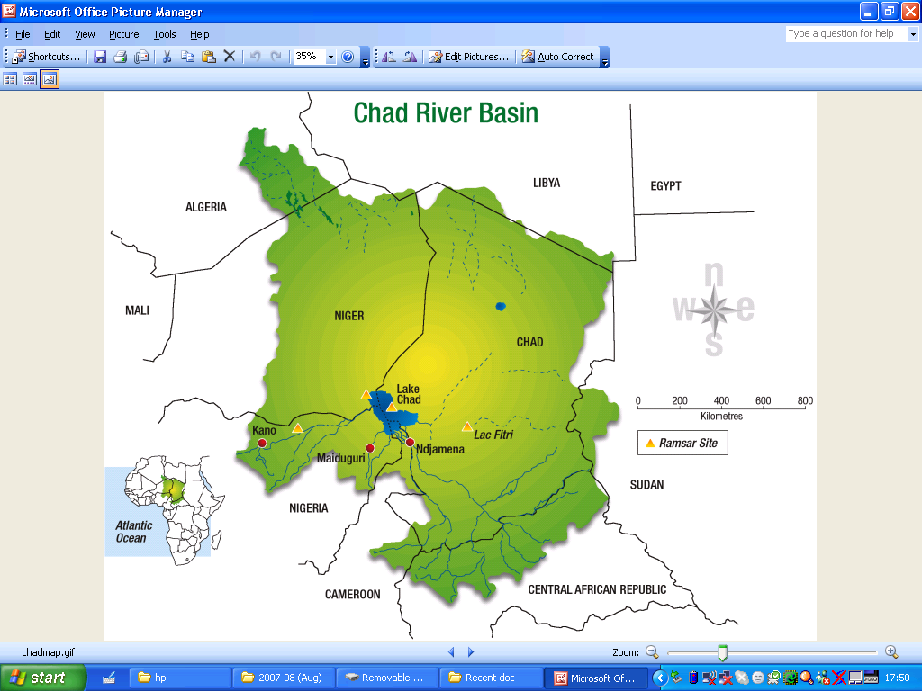
Annex 1: The Lake Chad Basin

  - Impact of Climate Change, Droughts

During the period spanning over 11,700 years ago, the Mega-Chad basin was full of water, occupying an area between 340-350, 000 km² with about 135 species of fresh fish and annual production estimated at 200,000 tonnes. Due to climate change, by 1960 the size of Lake Chad had reduced to 25,000 km². Since late 1960, due to increased human activities and series of droughts of high intensity and long duration saw the lake shrinking rapidly to 2,500 km² by 1985. The lake presently covers an area of less than 1,500 km² .

Due to increased pressure on the little resources left in the Lake, there has been mass migration of people and animals from place to place in search of water and greener pasture and consequently, resulting in unrests and conflicts, particularly the Boko Haram insurgency which all the countries of the region are currently confronting through the Multi National Joint Task Force.

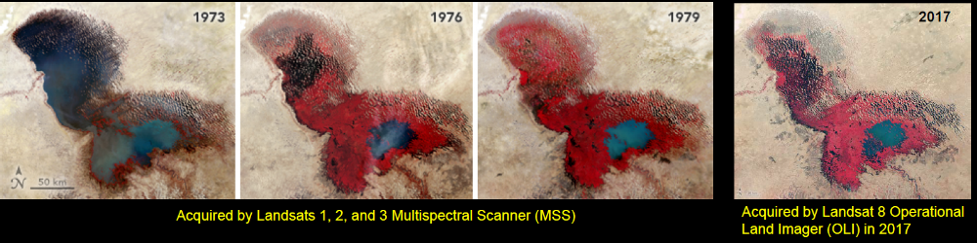
Annex 2

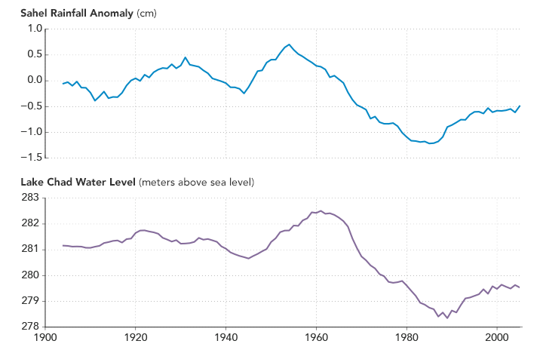

Annex 3
  - Hydrology and Dynamics of the Lake
Studies have shown a consistent change in the pattern of inflow and ouflow to the Lake since 1970 (Annex 4).

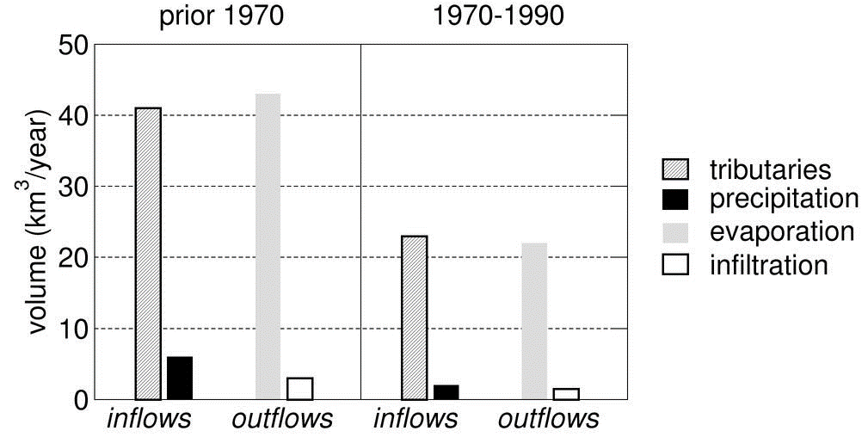

Annex 4

  - Need to Restore/save the Lake Chad
Large scale disasters in the Lake Chad region exacerbated by: loss of biodiversity and ecosystems degradation, shortage of water to meet all needs, decline in fishing activities, decline in irrigation activities, food insecurity, decline in income and consequent deterioration of living conditions, increase migration, increase competition and conflict over the little available resource and increase in crisis.

Facing the increasing degradation of Lake Chad ecosystem, the respective Governments of LCBC’s member countries to date took the following major measures:
- The African Ministers’ Conference on the Environment (AMCEN) in 1985 agreed to support the Lake Chad Basin Commission for an integrated development of the basin with the aim of halting the shrinking of the Lake and effective use of its natural resources.
- The Heads of State and Government of the Lake Chad Basin at the 10th Summit held in N’djamena, Chad on 28 July 2000 agreed to mobilize six million ($6m) US dollars for the feasibility study of Inter Basin Water transfer from Ubangi River in Central African Republic to the Lake Chad. To this effect, Nigeria supported the study with a grant of $5m. The LCBC Strategic Action Programme (SAP) was approved in 2008 and its implementation began with funding from AfDB and LCBC member States in the PRODEBALT Project;
- A Five-year Investment Plan (FYIP 2013-2017) aimed at safe guarding the ecosystem of the basin was adopted at the 14th Summit of LCBC Heads of State and Government held in N’Djamena, Chad on 30th April 2012. The plan had the following components:
- inter-alia, water transfer project from Ubangi River to Lake Chad;
- sensitization on the sustainable use of the natural resources and the preservation of the ecosystem of the Lake Chad Basin; strengthening stakeholders participation and implementation of the Lake Chad Basin Water Charter; and
- Implementation of the National Action Plan (NAP) for the Integrated Water Resources Management (IWRM) of the Lake Chad Basin member countries.
- The implementation of the NAP has commenced in Nigeria where the riparian States of the Basin have taken up the challenge to address the current issues by setting up a Trust Fund to implement activities contained in the Catchment Management Plan of the Komadugu-Yobe Basin (KYB).
- The Lake Chad Basin Water Charter was approved in 2012 by the LCBC Summit of the Head of State and Government as legal instrument for water management of the Lake. All LCBC’s member countries have ratified the charter except Libya and CAR that are in the process of doing so.
- Recently, LCBC and its six-member countries: Cameroon, Central African Republic, Chad, Libya, Niger, and Nigeria with support from the World Bank Group and in coordination with the French Development Agency/Agence Française de Development (AFD), have prepared the Lake Chad Development and Climate Resilience Action Plan (LCDAP) for the period of 2016- 2025. The core idea of the Plan is that, in parallel to the restoration of peace and security, there is a need to turn Lake Chad into a pole of regional rural development.

3 Outcome from the Conference
The Conference acknowledged:
- The various studies carried out showing that there is no solution to the shrinking of Lake Chad that does not involve recharging the lake by transfer of water from outside the basin.
- That Inter-basin water transfer is not an option; but a necessity.
- That failure to take appropriate and timely action, will result in Lake Chad completely drying up soon and that would cause humanitarian crisis, pose serious security challenges, not only for the region, but for the entire African continent and the World.
- The Transaqua Project which would take water from the right tributary of River Congo, conveying the water 2,000km channel to Chari River is the preferred feasible option (Annex 5).

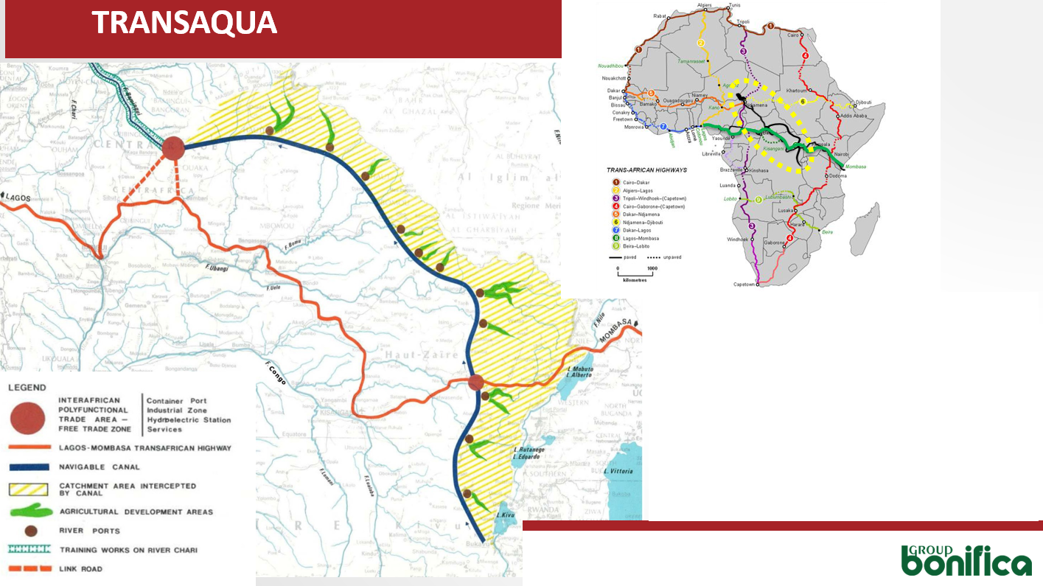
Annex 5: Transaqua Transfer Scheme

Therein, the Conference urged:
- The African Union to consider the consequences of Lake Chad disappearing not only as regional issue but, an African tragedy as part of its agenda, and endorse the Inter-Basin Water Transfer (IBWT) initiative as a Pan-African project to restore the Lake for peace and security to reign in the Lake Chad region and the promotion of navigation, industrial and economic development in the whole Congo basin.
- The International Technical and Financial Partners and Donors agree to support the Lake Chad Basin initiative through the financing of LCBC Development programmes aimed at addressing the problems caused by the shrinking of the Lake.
- The African Development Bank to facilitate the creation of the Lake Chad Fund of US $50 billion, to be sourced from African States and donations by Africa’s Development Partners to fund the Lake Chad IBWT and infrastructure projects.
3.1 Challenges and Opportunities
3.1.1 Challenges
- The interest of the various riparian states may differ and constitute great bottleneck for consensus on optimum solution to the initiative of restoring the Lake.
- Prevailing insurgencies, unrest/wars in the region and instability in government all, will hinder the timely execution of this important project.
- Illiteracy, poverty, migration of both people and livestock, population growth and insecurity in the region adjudged to be the highest in the world.
- Low precipitation, increased drought frequencies, high evaporation rate on the surface of the Lake and above all, hydrology of the lake is not well understood as to determine the inflow/outflow dynamics in the Lake and the pattern of changes taking place resulting in two distinct lakes, South and North Pools forming an archipelago of islands in between.
- Hydraulic carrying capacity of Chari River has not been established, at some sections, flooding occurs due to aggradation and siltation, while at other sections there is degradation and erosion due to changes in geomorphology and river regimes.
- Lack of full understanding of the nature of groundwater flow within the basin and its connectivity with the Nubian sandstone aquifer which could be a great source of ground water supply in the basin.
- Pollution of water within the conveyance system due to increased farming activities may lead to eventual eutrophication of the lake and require costly treatment systems for remediation and increase cost of the project.
- Deficiency in policy implementation, with little or no inclusion of monitoring mechanism (field and satellite), to ensure sustainable Lake Chad water resources management
- Lack of sufficient data and inadequate data collection network for validation and value addition and enhancement of decision making for sustainable water management.
- Lack of technical know-how, skilled manpower (water engineers, irrigation specialist, scientists, economists, sociologists, environmentalists and technicians) to handle the complexity of the engineering projects.

3.1.2 Opportunities
- Increased awareness of the plight of the region by international community
- Determination of member states led by Nigerian government to find measures to stop the shrinking of Lake Chad.
- UNESCO preparedness to support the initiative and its willingness to promote the Lake status of Chad to World Heritage, include the IBWT as a priority in its ongoing and future projects to address the problems of the basin.
- Feasibility studies already undertaken with promising and favorable prospects of transferring water from outside the basin to replenish the Lake.
- Favorable disposition by donor countries and international agencies towards the IBWT project.

3.2 Legal and Institutional Framework
- The LCBC is weakened by political and financial issues and suffers a lack of effective institutional capacity and technical knowledge to tackle complex issues such as transboundary water transfers.
- There is no water allocation agreement existing between the riparian countries. Legal instruments to enforce agreements /weaknesses in the Fort Lamy Convention which was established in 1964.

3.3 Issues of Water Security
- Water demand for domestic, irrigation, livestock, hydropower and navigation purposes is increasing due to population growth and increase in economic activities
- Water balance in the basin further constrained by climate change

3.4 Security Challenges of Lake Chad and Ecosystem

4 Approach of the Road Map
4.1 Strategy, Future Plan and Deliveries
4.2 Short Term Goals
- Review and adopt implementation plan for restoration and revitalization of Lake Chad
- Ameliorating security threat
- De-silting, weeding and river training of rivers flowing into the lake
- Explore the possibility of rain water catchment alternative water scheme within the basin
- Build capacity of LCBC and Stakeholder Institutions through Collaborative arrangements with regional capacity building networks
- Establish hydrologic and hydrogeological data networks over the basin and develop research outfit to model and understand the hydrodynamics of the Lake.
- Undertake studies to establish the hydraulic conductivity of the Nubian sandstone aquifer with the basin.
- Finalise the ongoing feasibility study of Transaqua Project
- Conduct baseline survey of bio-diversity of the basin to develop genetic data bank of plant and animal species in the basin.
- Conduct Environmental Impact Assessment study of the preferred option for restoring the Lake with corresponding Environmental and Social Management Plan (ESMP)
- Develop and implement communication strategy for the restoration of the lake
- Review and implement Masterplan for Lake Chad
- Initiate the process for raising the US $50 billion Lake Chad Fund
- Establish social mobilization and strengthen communication strategy to involve stakeholders, promote publicity, raise awareness and education on rational water use and environmental management.
- Advocacy for Sustainable Use of Water Resources and Environmental Restoration
- Strengthen local and regional partnerships amongst existing institutions, viz LCBC/CISCO

4.3 Medium Term Goals
- Produce detail design of the preferred project
- Implement ESMP of the preferred option for restoration of the Lake.
- Explore the possibility of utilizing the abundant ground water reserve in the basin
- Develop and undertake catchment management of Logone-Chari and Congo watersheds and integrate with existing KYobe and Yedseram/Ngadda CMP.
- Develop and implement afforestation and greening programme of the Lake Chad basin to reduce evaporation loss.
- Promote ecological and biodiversity advancement

  - Long Term Goals
- Undertake the development of the Lake Chad to transform its environment for economic growth and stability of the region.
- Implement the integrated catchment management plan for the watersheds.

5 Financing Strategy
- Secure the US $50 billion Lake Chad Fund
- Adopt Tariff, Taxes and Transfer (3Ts) funding approach
- Explore social and economic principles, where social component of project is funded through public sources (from riparian countries: commitment must be higher than the existing level) and economic component is funded using public funds and loans.

6. Recommendations
- The African Union to endorse the Inter-Basin Water Transfer (IBWT) initiative as a Pan-African project to restore the Lake toward peace and security in the Lake Chad region and the promote navigation, industrial and economic development in the whole Congo basin.
- The International Technical and Financial Partners and Donors to support this Lake Chad Basin initiative through the financing of LCBC Development programmes aimed at addressing the problems caused by the shrinking of the Lake.
- The African Development Bank to facilitate the creation of the Lake Chad Fund of US $50 billion, to be sourced from African States and donations by Africa’s Development Partners to fund the Lake Chad IBWT and infrastructure projects.
- To handle the complex environmental and engineering challenges coming with the project there is need to strengthen and build capacity of LCBC.
- Strengthen security apparatus along the shores of the Lake to ensure commencement of studies and developmental activities.
- Develop database of the genetic resources and biodiversity within the Lake Chad Basin.
- Undertake studies to establish the hydraulic conductivity of the Nubian sandstone aquifer with the basin.
- Strengthen hydrological and hydro-geological network for data collection in the basin

